TASK 6: FEATURE DEVELOPMENT WITH BRANCHING
Dockerized Book Issue and Return System
Name: Swar Sawalkar
Roll No.: 23104B0023
Department: CMPN | Year: Fourth Year
Division: C

1. Aim
To implement a core feature of the Dockerized Book Issue and Return System using Git feature branching, perform version control operations, and merge the completed feature into the development branch through GitHub.
2. Theory
Git is a distributed version control system used to track source-code changes and support collaboration. Feature branching allows developers to implement new functionality independently without directly modifying the main development branch.
In this project, a feature branch is used to implement the book issue and return workflow. Git commands such as add, commit, push, and merge maintain the development history. A pull request allows the changes to be reviewed before merging them into the develop branch.
3. Procedure / Implementation
- Open the project repository in GitHub Codespaces or a terminal.
- Check the current branch and working-tree status.
- Create a separate feature branch for the book issue and return functionality.
- Implement the feature using the appropriate controller, service, repository, and model classes.
- Test the workflow to ensure that a book can be issued when available and returned correctly.
- Stage and commit the modified files with a meaningful commit message.
- Push the feature branch to GitHub.
- Create a pull request from the feature branch to develop.
- Review the changes and merge the pull request after verification.
- Confirm that the changes are available in the development branch.
4. Git Workflow Diagram
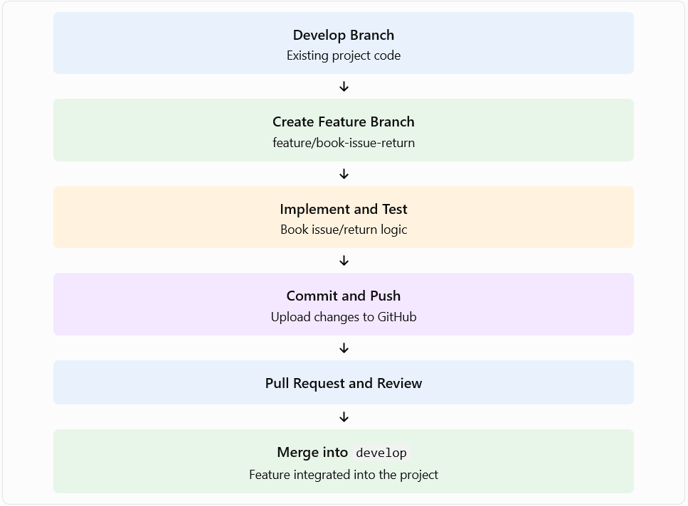
5. Commands Used
Run these commands from the project root:
git status
git branch --show-current
git switch develop
git pull origin develop
git switch -c feature/book-issue-return
# Implement and test the feature
mvn clean test
git add .
git commit -m "Add book issue and return feature"
git push -u origin feature/book-issue-return
After pushing, create a pull request on GitHub from feature/book-issue-return into develop. Merge it after reviewing and testing the changes.
Verify the branch and commit history:
git log --oneline --graph --all
git branch -a
6. Deliverables
Attach the following evidence to your practical report:
- Screenshot of the feature branch in GitHub or the terminal.
- Screenshot of the implemented book issue and return functionality.
- Terminal output showing successful tests, if they pass.
- Git commit history showing the feature commit.
- GitHub pull request showing the source and target branches.
- Screenshot of the merged pull request or updated develop branch.
7. Result
The feature-branch workflow was defined for implementing the book issue and return functionality. The changes are intended to be tested, committed, pushed to GitHub, reviewed through a pull request, and merged into the develop branch.
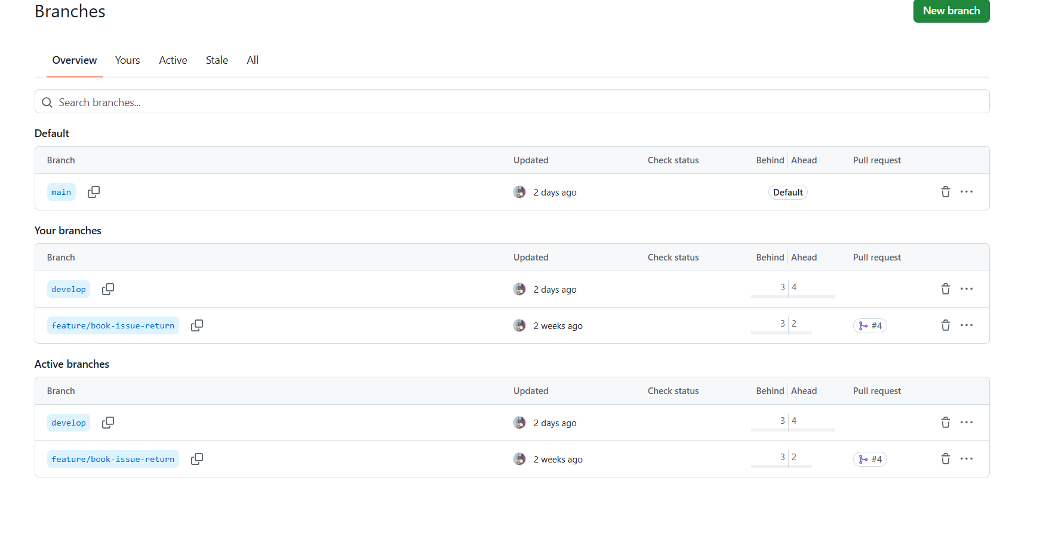

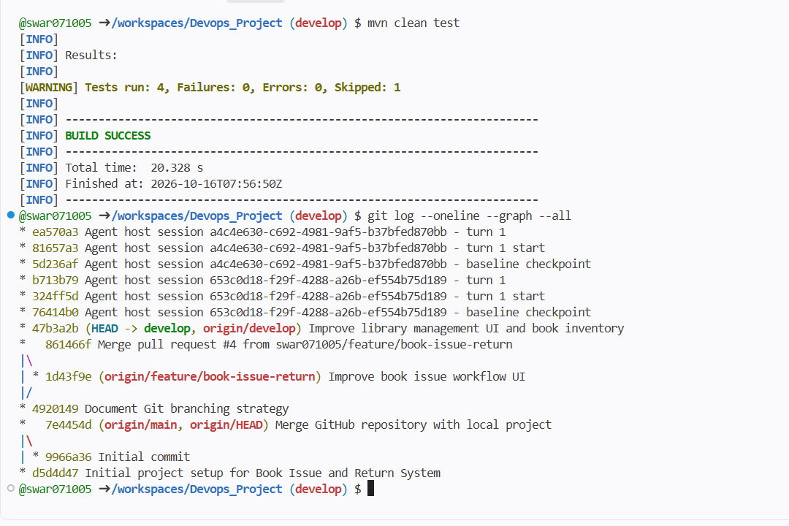
8. Conclusion
Feature branching provides an organized way to develop new functionality without directly affecting the development branch. Using Git commits and pull requests improves collaboration, traceability, code review, and the reliability of the Dockerized Book Issue and Return System.

